Use Mobile Center to quickly get the insights that your app users won't tell you

# Overview

Mobile Center brings together multiple services, commonly used by mobile developers, into a single, integrated product. You can build, test, distribute, and monitor your mobile apps and easily add backend cloud services to scale your app to millions of users on demand.

# Objectives

* Create a native iOS application.
* Create a Mobile Center app.
* Integrate the iOS Native project with the Mobile Center app.
* Track app analytics and events to Mobile Center.

# Prerequisites

* Mac OS X
* Xcode
* A Mobile Center account ([https://mobile.azure.com](https://mobile.azure.com/))
* Apple ID (<https://appleid.apple.com/account>)

# Intended Audience

This Quick Start Challenge is intended for developers who are familiar with iOS development.

# Task 1: Create a iOS Native app

1. You will need Xcode.

The simplest way to install Xcode is to open the Mac App Store and search for Xcode, then click the GET button. This will automatically install the Xcode software.  
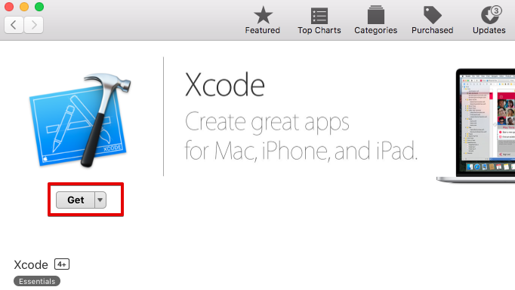

1. Create project.

Once Xcode installation process finished open Xcode. You will see a prompt window with different options. Select “Create a new Xcode project” or select File > New > Project in the menu bar.

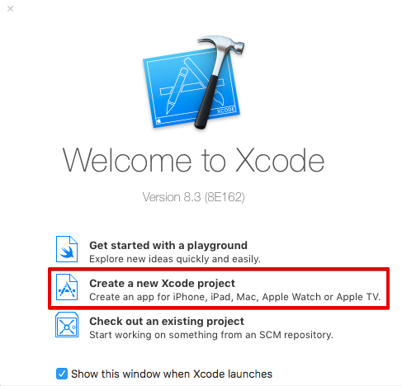

Then choose “Single View Application” and press Next.

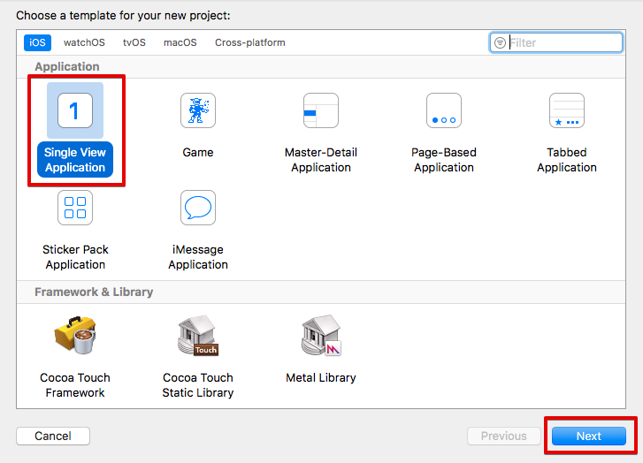

In the next dialog give a product name, select Swift language, uncheck checkboxes and press Next.

**Note:** Do not name your project with “MobileCenter” as it will conflict with MobileCenter framework.

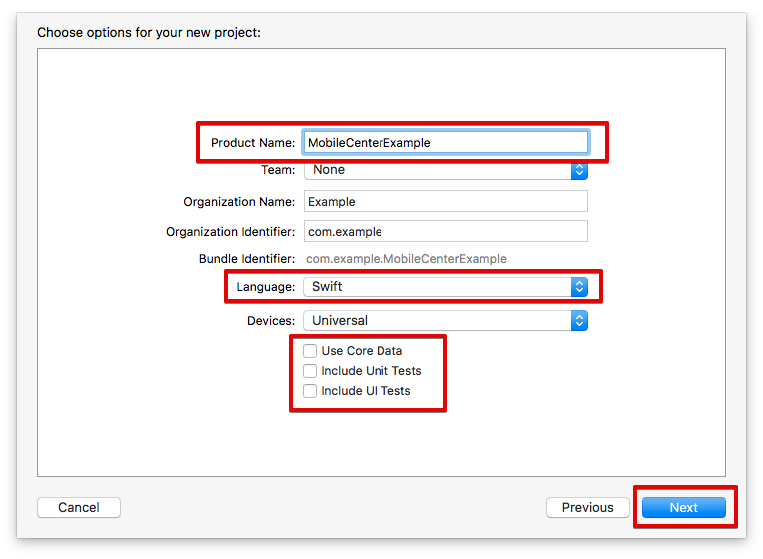

In the next dialog select appropriate location for the project and press Create button.

Now you can run your project in a simulator by pressing ⌘ + R or choosing Product > Run in the menu.

In order to run the project on your device you need to configure Apple account. Open project settings as shown in the picture below and in the Signing section press on a Team selection.

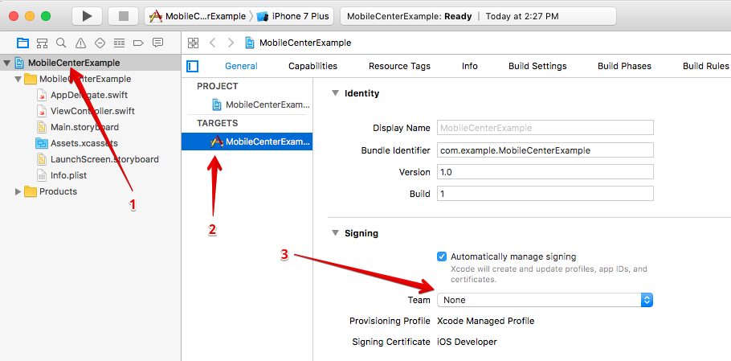  
In the following selection press on “Add an account”. Fill in Apple ID credentials and press “Sign In” or create new account by pressing “Create Apple ID” if you doesn't have one.

Now you can select your device as shown below and run the application.

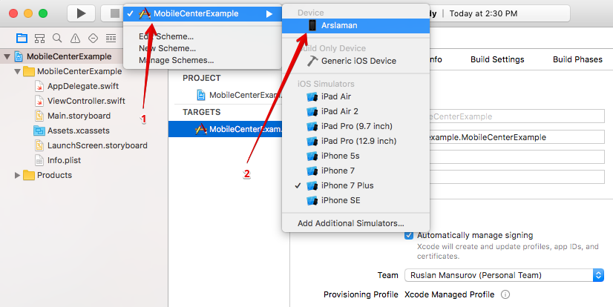

# Task 2: Create the Mobile Center app

1. Log in to your Mobile Center account at [https://mobile.azure.com](https://mobile.azure.com/).
2. From the top right corner, select **Add new | Add new app**.

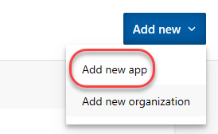

1. Enter a **Name** of **“Build App”** and set it to be for **iOS** using **Objective-C / Swift**. Click **Add new app**.

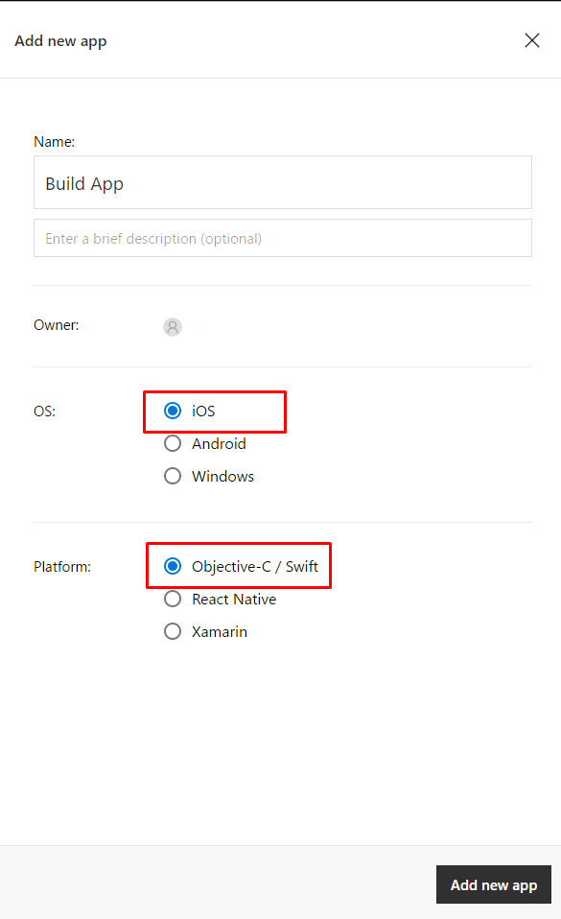

# Task 3: Integrate the iOS native app with Mobile Center

1. If you haven’t already, install CocoaPods by [downloading the app](https://cocoapods.org/app) or by running this command in a terminal:  
   

Should you not already be using CocoaPods, create a Podfile by running *pod init* in your app’s root directory.

Add the following to your Podfile in a target section to include all Mobile Center services in your app:  
*pod 'MobileCenter'*

Save the file and run this command in the terminal:

1. Open the project using the .xcworkspace file located in your app’s root directory.
2. Open AppDelegate.swift file and add the following lines below your own import statements.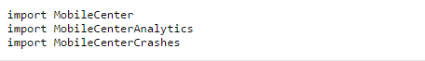

In the same file, add the following in your didFinishLaunchingWithOptions delegate method.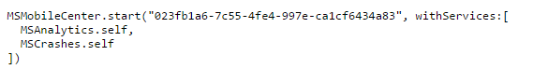

Now build and launch your app, then go to the Analytics section. You should see one active user and at least one session! The charts will get more relevant as you get more users.

# Task 4: Adding event tracking to the app

1. It may take a while for the analytics to begin to appear in Mobile Center, so we’ll move on to the next task and add in some event tracking.
2. Immediately after the **MobileCenter** line of code added previously, add the line of code below. It’s a relatively straightforward request to track a text event.

MSAnalytics.trackEvent("Session was started")

1. Run your project. Keep in mind that while we’re using Mobile Center for an iOS native application, Mobile Center supports every major platform out there. As a result, you should check out the guidance for integrating other platform combinations with the Mobile Center events guidance at <https://docs.microsoft.com/en-us/mobile-center/analytics/understand-events>.
2. Return to the Mobile Center browser window. Select the **Analytics** tab.

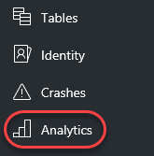

1. By now, the first user session should have been processed for display. If not, try refreshing the window every few seconds until it appears. Note that you can scroll down the page to get insight about the sessions, devices, geographies, and languages of your users, as well as reporting of the breakdown of devices per version.

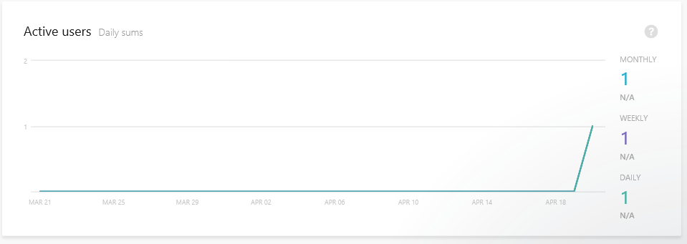

1. Select **Analytics | Events**.

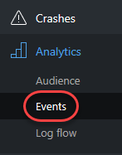

1. If the events haven’t started showing up yet, try refreshing the browser. If you run the application multiple times, then the count should increment each time you do.

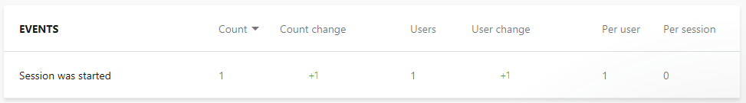

1. Select **Analytics | Log flow**.

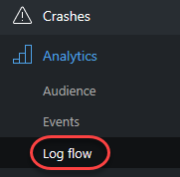

1. Log Flow will show you in real time what is being received by the backend. While the transmission may be delayed by a few seconds, this is a great place to get immediate notifications about sessions tarts, crashes, and events.

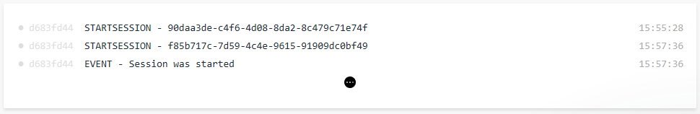

# Summary

Congratulations on completing this Quick Start Challenge! In this lab, you’ve learned how to use Mobile Center to instrument and monitor your mobile apps in development and production.

# Additional Resources

If you are interested in learning more about this topic, you can refer to the following resources:

**Documentation**: <https://docs.microsoft.com/en-us/mobile-center/>

**GitHub SDK**: <https://github.com/Microsoft/mobile-center-sdk-ios>

**Team blog**: <https://blogs.msdn.microsoft.com/visualstudio/tag/visual-studio-mobile-center/>